Alg 4 Summer Name: ____________________________

______________ _____________

WS Assessment

Target 1:

SOLVING QUADRATIC EQUATION

**I can:**

* Solve quadratic equation using different methods: Factoring, Squaring (Complete the square), Formula, Graphing, and Programming.

**Unit 7: Quadratic and Complex number**

* [**HSN.CN.A.1**](http://www.corestandards.org/Math/Content/HSN/CN/A/1/): Know there is a complex number *i* such that *i*2 = -1, and every complex number has the form *a + bi* with *a* and *b* real.
* [**HSN.CN.A.2**](http://www.corestandards.org/Math/Content/HSN/CN/A/2/): Use the relation *i*2 = -1 and the commutative, associative, and distributive properties to add, subtract, and multiply complex numbers.
* [**HSN.CN.C.7**](http://www.corestandards.org/Math/Content/HSN/CN/C/7/): Solve quadratic equations with real coefficients that have complex solutions.

We learn **five** different ways to solve quadratics equations

Solve by **factoring** : Steps: Factor the tri-nomial first, then set each pair = 0 and solve it

1. 9x2 – 20x – 21 = 0 🡪 ( ) = 0 ( ) = 0 = ?

2. 4x2 + 13x – 35 = 0 🡪 ( ) = 0 ( ) = 0 = ?

3. 10x2 + 37x – 36 = 0 🡪 ( ) = 0 ( ) = 0 = ?

4. 9x2 + 18x + 8 = 0 🡪 ( ) = 0 ( ) = 0 = ?

5. 8x2 – 33x + 27 = 0 🡪 ( ) = 0 ( ) = 0 = ?

Solve by **squaring** (complete the square using the box)

1. 9x2 – 20x – 21 = 0

2. 4x2 + 13x – 35 = 0

3. 10x2 + 37x – 36 = 0

4. 9x2 + 18x + 8 = 0

5. 8x2 – 33x + 27 = 0

Solve by quadratic **formula**

1. 9x2 – 20x – 21 = 0

2. 4x2 + 13x – 35 = 0

3. 10x2 + 37x – 36 = 0

4. 9x2 + 18x + 8 = 0

5. 8x2 – 33x + 27 = 0

Solve by **graphing**: Use intersect. Sketch out the graph and show the x-intercept

1. 9x2 – 20x – 21 = 0 y= 9x2 – 20x – 21 y = 0

2. 4x2 + 13x – 35 = 0 y=? y=?

3. 10x2 + 37x – 36 = 0 y=? y = ? Stamp

4. 2x2 + 3x + 20 = 0 y=? y = ?

Solve by **Programming**

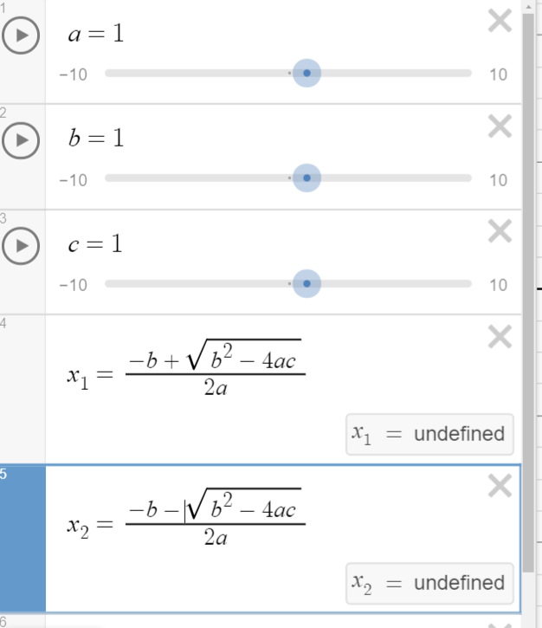Solve (Stamps)

1. 9x2 – 20x – 21 = 0

2. 4x2 + 13x – 35 = 0

3. 10x2 + 37x – 36 = 0

4. 9x2 + 18x + 8 = 0

5. 8x2 – 33x + 27 = 0

Solve the following using all five methods

x2 – 3x – 4 = 0

**Assessment Target 1   
I can…** Solve a quadratic equation using different method  
**Solve by factoring.   
1.** 3x2 – 11x – 42 = 0 **2.** 7x2 – 6x – 1 = 0 **3.** 2x2 + 15x + 28 = 0

**Solve by squaring (complete the square)**

**4.** x2 – 18x + 42 = 0 **5.** 2x2 – 16x – 18 = 0 **6.** 3x2 + 6x – 9 = 0

**Solve with the quadratic Formula**

**7.** 5x2 – 8x – 48 = 0 **8.** 4x2 – 8x – 5 = 0 **9.** 2x2 + 11x + 9 = 0

**10**. Solve by graphing and programming (After you have done, I pick a problem, you show me and get stamp)